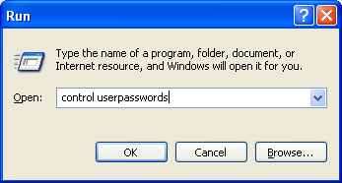
(shortcut to Start > Control Panel > User Accounts)

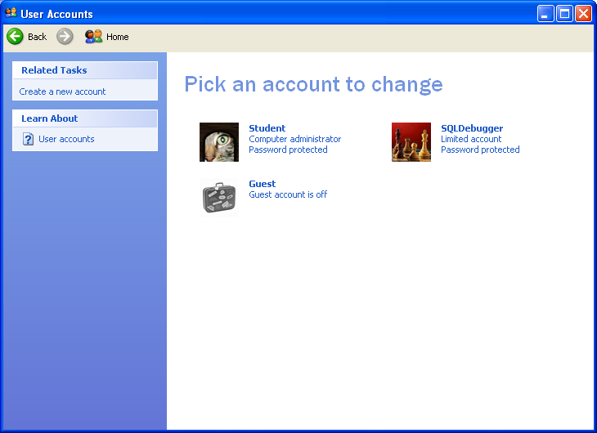
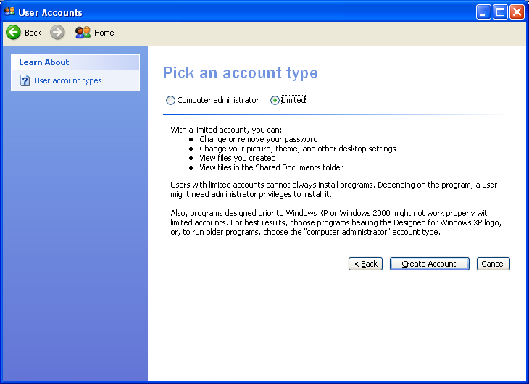
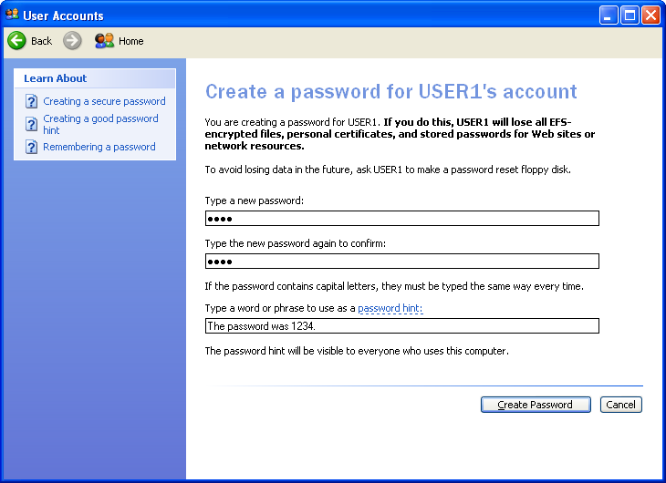

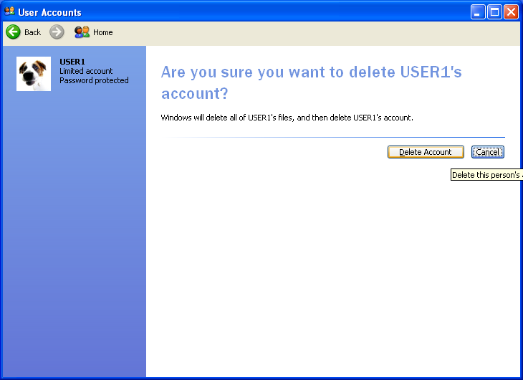

Summary
Originally, this didn’t work because of security restrictions on the other login. It works on this one though. Normally, I edit users through compmgmt.msc (Computer Management). In all honesty, the new user accounts panel sucks. It doesn’t give you very much control over how limited a user should be. For example, this control panel doesn’t let you create a Power User. If a user needs a simpler interface, I recommend Start > Run > control userpasswords2, which is the old easy control panel from Windows 2000. In any event, user creation isn’t hard or anything, so I don’t think I have much to say. Every user, however, SHOULD create an alternate account from their Administrator account and use that.

